Ab Kettleby Neighbourhood Plan

Consultation Statement

Introduction
This Consultation Statement has been prepared to fulfil the legal obligations of the Neighbourhood Planning Regulations 2012. Section 15(2) of Part 5 of the Regulations sets out what a Consultation Statement should contain. According to the Regulations, a Consultation Statement:

- Contains details of the persons and bodies who were consulted about the proposed Neighbourhood Development Plan;

- Explains how they were consulted;

- Summarises the main issues and concerns raised by the persons consulted;

- Describes how these issues and concerns have been considered and, where relevant, addressed in the proposed Neighbourhood Plan.

This document provides a record of the engagement that took place at the various stages of the plan’s evolution. The main methods used to publicise the consultation and engagement process are documented, along with the main findings from the engagement.

Figure 1 – Ab Kettleby Neighbourhood Plan Area designated on 18th January 2016

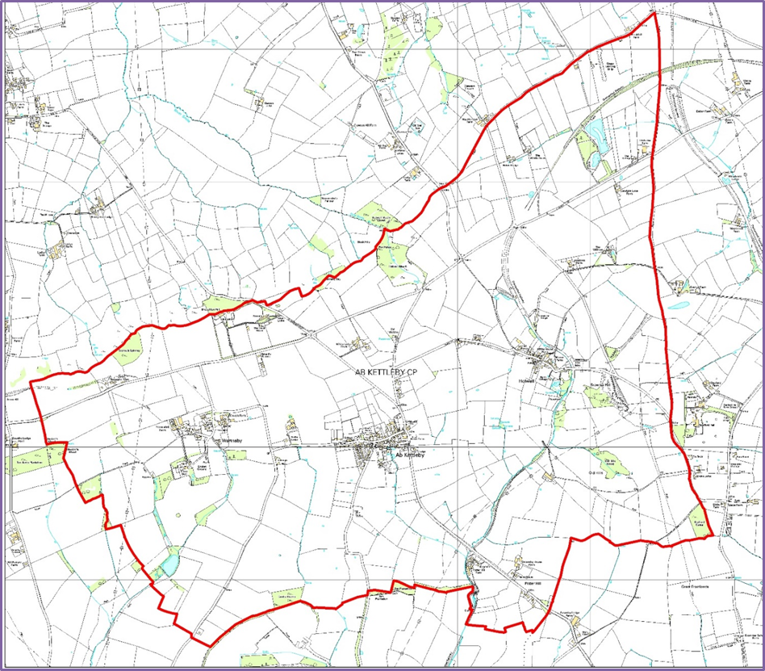
Regulations and government guidance:
Stage 1: Deciding to make a Neighbourhood Plan

The Parish Council of Ab Kettleby formally took the decision to undertake a Neighbourhood Plan at a Parish Council meeting on 16 June 2016. The first meeting of the Neighbourhood Plan Advisory Committee took place on 15 August 2016

Stage 2: Defining the neighbourhood
The Parish Council applied to Melton Borough Council on 17th September, 2015 to designate the neighbourhood as identified above. The correspondence is attached as Appendix 1.
A formal engagement period provided members of the public and other key stakeholders an opportunity to submit comment on the proposed Neighbourhood Plan Area and proposed Neighbourhood Planning Body for Ab Kettleby. The proposed Neighbourhood Planning Body was Ab Kettleby Parish Council and the proposed Neighbourhood Planning Area is shown in Figure 1 above.
Melton Borough Council checked that the application was appropriate and undertook the appropriate notification process. The designation was made on 18th January, 2016.

Stage 3: Preparing the plan
Ab Kettleby Neighbourhood Plan Advisory Committee is a Committee of Ab Kettleby Parish Council. There are Parish Councillors and members of the public on the Committee. The Committee has an elected Chair and an approved constitution.
The Advisory Committee has worked to produce a draft plan, ensuring that it:
- Is in general conformity with the Melton Local Plan;
- Has regard for national planning policies;
- Is in line with other legal frameworks;
- Is mindful of the need to contribute to sustainable development;
- Has been prepared on the basis of sound governance arrangements.
Ab Kettleby Neighbourhood Plan seeks to establish specific and local planning policies for the development and use of land in the Parish. The neighbourhood plan establishes a vision for the future taking into account the data gathered through community engagement and consultation alongside demographic and socio-economic data. The Parish Council appointed YourLocale as consultants to help create the plan.
The Advisory Committee met on the following dates:
25th September 2016, 25th October 2016, 29th November 2016
24th January 2017, 21st February 2017, 3rd April 2017, 2nd May 2017, 1st August 2017
9th October 2018, 29th January 2018, 25th April 2018, 31st July 2018.

Minutes of all Advisory Committee meetings can be found on the Ab Kettleby Parish Council website
In May 2017, three theme groups were launched to pull together and prioritise ideas emerging from the first consultation and start to work up their plans.
- The Housing Theme Group met 4 times between 14th June 2017 and 6th September 2017.
- The Environment Theme Group met 11 times between 22nd May 2017 and 11th December 2017.
- The Community Facilities, Employment and Transport Theme Group met 3 times between 26th June 2017 and 14th August 2017.

Communications
Below are listed the main ways that information about the Neighbourhood Plan has been communicated with local people and stakeholders.

- Village noticeboards and notices in the Sugar Loaf Public House displaying details of consultation events and meetings.

- Leaflets/ flyers and a hard copy of the questionnaire were distributed to every household in the Parish inviting residents to complete the questionnaire and attend the the April 2017 Open Event. The June 2018 Open Event was also promoted with a leaflet drop to every household in the Parish.

- “Village Life” Parish News Sheet Notification of the intention to produce a Neighbourhood Plan and the formation of the Advisory Group was printed in Village Life in November 2016. The questionnaire and both Open Events were also advertised in the Village Life which is hand delivered to every household by volunteers monthly.

- Ab Kettleby Parish Council website: KNPG agendas, minutes, monthly updates, the questionnaire and all consultation results were posted on the site from autumn 2016.

Stakeholder letters/email:
  - A letter was sent to stakeholders in early March 2017 advising them that the parish council was producing a Neighbourhood Plan, inviting them to complete the questionnaire and attend the Open Event on 8th April 2017.
  - All stakeholders were contacted by letter in advance of the Regulation 14 consultation period between 11th May 2018 and 21st June 2018.
  - Owners of all proposed Local Green Space, Important Open Space & Local List sites were contacted separately by letter in early August 2018.

Formal Consultations
Several consultations have taken place, each building on the evidence of the last.

  - An initial community consultation event took place in the Primary School in Ab Kettleby on 8 April 2017 (Appendix 2);

  - A comprehensive Community Questionnaire was delivered to every household in April 2017 (Appendix 3);

  - A community consultation event focusing on the plan policies took place on 16 June 2018 (Appendix 4)

  - Regulation 14 consultation took place from 11 May to 21 June 2018. All comments and the changes made to the Pre-Submission Draft of the Neighbourhood Plan are attached as Appendix 5.

Consultation methodology
The consultations aimed:
    - To inform as many people as possible of the existence of the neighbourhood planning process
    - To seek the views of people from the community on the proposals being developed by the Advisory Committee.

Activities:
As well as meetings of Ab Kettleby Neighbourhood Plan Advisory Committee and the work of the theme groups the following activities were undertaken:
- Notices were placed on the Parish noticeboard and in the pub asking people to get involved and informing them of progress;
- All meeting agendas, minutes and key documents were posted on the Parish Council website;
- The local newsletter “Village Life” was used to promote the neighbourhood plan;
- The Neighbourhood Plan was included as a regular agenda item at Parish Council meetings. Minutes of all meetings are publicly available on the Parish Council website;
- A good working relationship was established with the Borough Council including dialogue and meetings at key stages;
- A staffed open event about the Neighbourhood Plan was held in April 2017. At this event people were asked to give their thoughts and ideas on priority issues for the Plan. The event was extensively publicised;
- A community questionnaire was undertaken in April 2017 (questionnaire can be viewed on Parish Council website);
- A second staffed exhibition took place in June 2018 at which the community was presented with the draft policies. The plans and policies were available to view in large format on presentation boards. Again the event was extensively publicised;
- Agencies with a statutory or other significant interest in the Plan were invited to submit their comments in writing by email and letter, at appropriate stages of the planning process, according to the regulations.

Detailed consultation and activities:

The Advisory Committee’s mandate was to drive the process, consult with the local community, gather evidence to support emerging policies and deliver the Plan.

Contacting Stakeholders
The first task was to contact statutory and local stakeholders and announce the commencement of the Neighbourhood Plan process. The following stakeholders were contacted at the outset:

A local planning authority, county council or parish council any part of whose area is in or adjoins the area of the local planning authority:

County Council - Nik Green, Communities and Places Officer, Leicestershire County Council, Nik.Green@leics.gov.uk

James Beverley, Planning Policy Officer, Regulatory Services
Melton Borough Council, Jbeverley@melton.gov.uk

Asfordby Parish Council: Clerk: Claire Dorans, 24 Main Street, Asfordby, Melton Mowbray, Leics, LE14 3SAc lerk@asfordbypc.org.uk
Grinton, Saxelby and Shoby Parish Council: Parish Clerk: Mary Fenton Saxelbye Road Farm, Asfordby Melton Mowbray LE14 3TU
Scalford Parish Council: Clerk: Chris Hill, 43 Bowley Avenue, Melton Mowbray, Leics, LE13 1RU.
Broughton and Old Dalby Parish Council: Clerk: Lucy Flavin, Broughton Cottage, 60 Main Road, Nether Broughton, Leicestershire, LE14 3HB. broughtondalbypc@outlook.com
Clawson Hose and Harby Parish Council: Parish Clerk: Liz Crowther 11 Harby Lane, Hose, Melton Mowbray LE14 4JR clerk@chhparishcouncil.co.uk
The coal authority

Deb Roberts, Planning Liaison Officer, The Coal Authority, 200 Lichfield Lane, Mansfield, Nottinghamshire, NG18 4RG thecoalauthority@coal.gov.uk

The Homes and Communities Agency

Homes and Communities Agency, 5 St Philip’s Place, Colmore Row
Birmingham , B3 2PW

Natural England

Miss C Jackson, Consultation Service, Natural England, Hornbeam House, Electra Way, Crewe, Cheshire, CW1 6GJ enquiries@naturalengland.org.uk

The Environment Agency

Mark Candlin, Environment Agency, Lower Trent Area, Trentside Offices, Scarrington Road, West Bridgeford, Nottingham, NG2 5FA mark.candlin@environment-agency.gov.uk
Naomi.doughty@environment-agency.gov.uk
geoff.platts@environment-agency.gov.uk
Environment Agency Trentside Offices Scarrington Road West Bridgford Nottingham, NG2 5BR.

Historic England/English Heritage

Historic England. eastmidlands@HistoricEngland.org.uk
2nd floor, Windsor House, Cliftonville, Northampton, NN1 5BE

Ann Plackett, English Heritage, East Midlands Region, 44 Derngate
Northampton, NN1 1UH

Network Rail Infrastructure Limited

Network Rail Infrastructure Limited, Kings Place, 90 York Way
London, N1 9AG

The Highways Agency

Ms Aoife O'Tool, Highways Agency, Level 9, The Cube
199 Wharfside Street, Birmingham B1 1RN

Any person i. to whom the electronic communications code applies ii. who owns or controls electronic communications apparatus in the area

British Telecommunications Plc, Customer Wideband Planning Group
Post Point BSTE 0301, Bath Street, Nottingham NG1 1BZ

Primary Care Trust

East Leicestershire and Rutland CCG, Suite 2 and 3, Bridge Business Park
674 Melton Road, Thurmaston, Leicester, LE4 8BL

Licence holder under the Electricity Act 1989

FAO Mr D Holdstock, National Grid, AMEC Environment & Infrastructure UK Limited, Gables House, Kenilworth Road, Leamington Spa, Warwickshire, CV32 6JX

Licence holder under the Gas Act 1986

British Gas Properties, Aviary Court, Wade Road, Basingstoke
Hampshire, RG24 8GZ

Sewage Undertaker/Water undertaker

Mr Peter Davies, Severn Trent Water Ltd, Hucknall Road
Nottingham, NG5 1FH

Stuart Patience, Planning Liaison Officer, Anglian Water Ltd, Planning & Equivalence Team, Thorpe Wood House, Thorpe Wood, Peterborough, PE3 6WT spatience@anglianwater.co.uk

Voluntary bodies some or all of whose activities benefit all or part of the neighbourhood area

Voluntary Action Leicestershire admin@vasl.org.uk

Roy Holland. Age UK Leicestershire and Rutland roy.holland@ageukleics.org.uk

CPRE info@cpreleicestershire.org.uk

Bodies which represent the interests of different racial, ethnic or national groups in the neighbourhood area

Leicestershire Ethnic Minority Partnership Prakash@lemp-leics.org.uk

Federation of Gypsy Liaison Groups info@gypsytravellerfederation.org

Bodies which represent the interests of different religious groups in the neighbourhood area

Interfaith Forum for Leicestershire equality@leics.gov.uk

Bodies which represent the interests of persons carrying on business in the neighbourhood area

Melton Mowbray Chamber of Commerce. Harwood House Annex, 3C Park Road, Melton Mowbray, Leicestershire, LE13 1TT

Bodies which represent the interests of disabled persons in the neighbourhood area

Leicestershire Centre for Integrated Living. 5-9 Upper Brown Street, Leics, LE1 5TE www.lcil.org.uk

Planning Specialist - Leicestershire
Sustainable Places - Planning Team, County Hall, Glenfield, Leicestershire

Melton Borough Access Group nslater@melton.gov.uk

Other Bodies

Leicestershire Police, Force Headquarters, St Johns, Enderby, Leicester,
LE19 2BX

Leicestershire Fire and Rescue, 12 Geoff Monk Way, Birstall, Leicester LE4 3BU

Councillors/MPs

MP: Alan Duncan duncana@parliament.uk

County Councillor: Joe Orson
joe.orson@leics.gov.uk
District Councillor: Joe Orson joe.orson@leics.gov.uk
Local businesses/church/pub/other groups
Rev. Canon Peter Hooper, The Rectory, 2 Church Lane, Asfordby, Leics LE14 3RU email: peter@hoppers.orangehome.co.uk

Churchwardens and PCC of St Leonards Church, c/o Roger Tucker, 3 Nursery Lane, Holwell, Leics LE14
4UF email: advice@farringdone.co.uk

Holwell Village Hall Association Ltd, Chairman, David Harris, 35 Main Street, Holwell, Leics LE14 4SZ

Simon Bentley, Leicestershire and Rutland Wildlife Trust, The Old Mill, 9 Soar Lane, Leicester, LE3 5DE email: info@lrwt.org.uk

Holwell Pastures Camp c/o Melton District Scouts, 133 Sandy Lane, Melton Mowbray, Leicestershire, LE13 0AW e-mail: dbfraser@ntlworld.com

St James PCC c/o Jill Woodcock, 6 Melton Road, Ab Kettleby, Melton Mowbray LE14 3JA

Ian Toon, Ab Kettleby Primary School, Wartnaby Road, Ab Kettleby, Melton Mowbray LE14 3JJ email: admin@abkettleby.org

The Sugar Loaf, 2 Nottingham Road, Ab Kettleby, Melton Mowbray LE14 3JB

GRS Car Care, White Lodge Farm, Nottingham Road, Ab Kettleby, Melton Mowbray, Leicestershire, LE14 3JB email: enquiries@grscarcare.co.uk

St Michaels and All Angels, Wartnaby PCC, c/o David Musson, Stonepits Farm, Wartnaby LE14 3JQ

Geoff Johnson, The Estate Office, Friars Well Estate, Wartnaby, Melton Mowbray LE14 3HY

Other Friars Well Estate businesses all LE14 3HQ:

Cherizena Coffee Limited, The Granary, Friars Well Estate, Wartnaby, Leicestershire, LE14 3HQ email: info@cherizena.co.uk

Shabby Store, The Finings, Friars Well Estate

Sebastian Graff-Baker, Andersons, Old Office, Friars Well Estate

Magnetic North, West Lodge, Friars Well Estate

Holmes Investments, Upstairs in Lodge, Friars Well Estate

Heritage Interactive, The Paddocks, Friars Well Estate

All Purpose Cleaning Supplies, The Maltings, Friars Well Estate

Howzat Travel, The Pavillion, Friars Well Estate

HP Industries, Tamworth Lodge, Friars Well Estate

Safehold Storage, Friars Well Estate, Friars Well Estate

Mr P Huber, Race DNA, The Long Barn, Church Farm, Wartnaby, LE14 3HU

Mr B Musson, David Musson Fencing, Stonepits Farm, Wartnaby, Melton Mowbray, Leics LE14 3JQ
The same groups, individuals and organisations have been consulted as part of the Regulation 14 consultation arrangements.

Conclusion
Comments from respondents to the Regulation 14 Consultation have helped to shape the draft Neighbourhood Plan prior to submission to Melton Borough Council.

The draft Neighbourhood Plan is now ready to be submitted for Regulation 16 consultation to Melton Borough Council, who will publicise it for a further six weeks and then forward it, with accompanying documents and all representations made during the publicity period, to an Independent Examiner who will review it and check that it meets the ‘Basic Conditions’.

If the Plan successfully passes this stage, with any modifications, it will be put forward for referendum.

The referendum question will be a straight “yes” or “no” on the entire Plan, as set out by Neighbourhood Planning Regulations. People will not be able to vote for or against individual policies. If 50% or more of those voting vote for the Plan, it will be brought into force (‘Made’) and become part of Borough-wide planning policy.
This Consultation Statement and the supporting Appendices are provided to comply with Section 15(2) of part 5 of the 2012 Neighbourhood Planning Regulations.

Victoria Pashley

Clerk

Ab Kettleby Parish Council

August 2018

