Scalford Neighbourhood Plan

Consultation Statement

Introduction
This Consultation Statement has been prepared to fulfil the legal obligations of the Neighbourhood Planning Regulations 2012. Section 15(2) of Part 5 of the Regulations sets out what a Consultation Statement should contain. According to the Regulations, a Consultation Statement:

- Contains details of the persons and bodies who were consulted about the proposed Neighbourhood Development Plan;

- Explains how they were consulted;

- Summarises the main issues and concerns raised by the persons consulted;

- Describes how these issues and concerns have been considered and, where relevant, addressed in the proposed Neighbourhood Plan.

This document provides a record of the engagement that took place at the various stages of the plan’s evolution. The main methods used to publicise the consultation and engagement process are documented, along with the main findings from the engagement.

Figure 1 – Scalford Neighbourhood Plan Area designated 19th October 2017

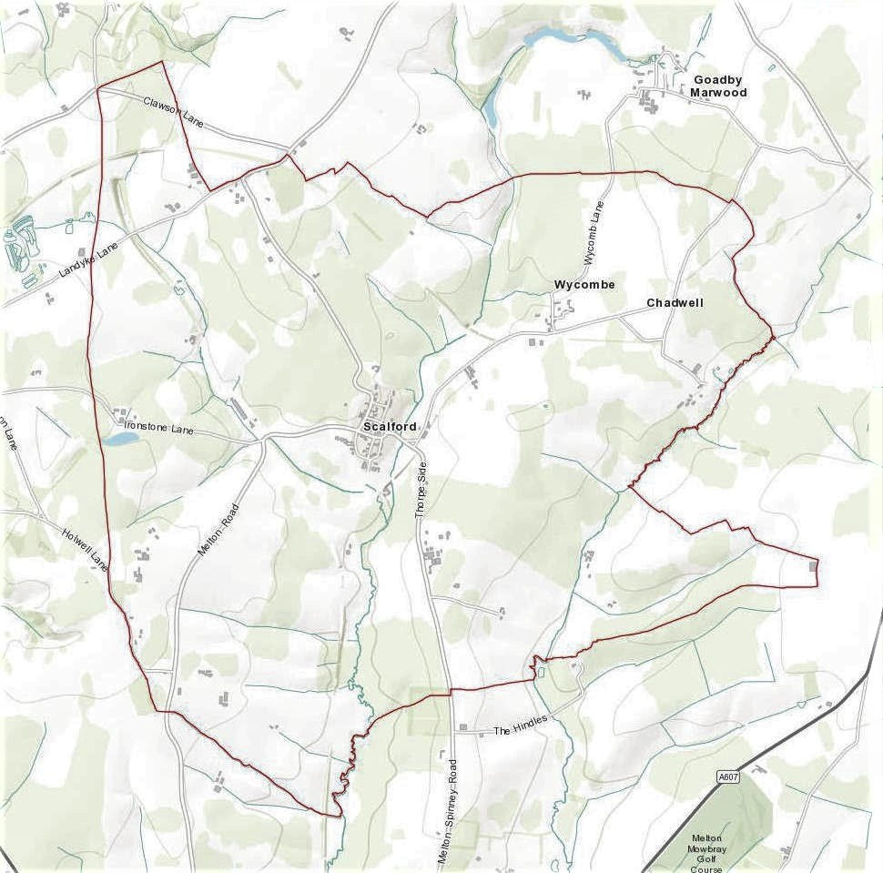
Regulations and government guidance:
Stage 1: Deciding to make a Neighbourhood Plan

The Parish Council of Scalford formally took the decision to undertake a Neighbourhood Plan at a Parish Council meeting on 11 October 2017. An initial meeting of the Neighbourhood Plan Advisory Committee took place on 25 April 2018 with first formal minuted meeting on 21St May 2018

Stage 2: Defining the neighbourhood
The Parish Council applied to Melton Borough Council on 12th October 2017 to designate the neighbourhood as identified above.
A formal engagement period provided members of the public and other key stakeholders an opportunity to submit comment on the proposed Neighbourhood Plan Area and proposed Neighbourhood Planning Body for Scalford. The proposed Neighbourhood Planning Body was Scalford Parish Council and the proposed Neighbourhood Planning Area is shown in Figure 1 above.
Melton Borough Council checked that the application was appropriate and undertook the appropriate notification process. The designation was made on 19th October 2017 recorded in the minutes of the Parish Council on 6th December 2017.

Stage 3: Preparing the plan
Scalford Neighbourhood Plan Advisory Committee is a Committee of Scalford Parish Council. The Committee has an elected Chair and an approved constitution.
The Advisory Committee has worked to produce a draft plan, ensuring that it:
- Is in general conformity with the Melton Local Plan;
- Has regard for national planning policies;
- Is in line with other legal frameworks;
- Is mindful of the need to contribute to sustainable development;
- Has been prepared on the basis of sound governance arrangements.
Scalford Neighbourhood Plan seeks to establish specific and local planning policies for the development and use of land in the Parish. The neighbourhood plan establishes a vision for the future taking into account the data gathered through community engagement and consultation alongside demographic and socio-economic data. The Parish Council appointed YourLocale as consultants to help create the plan.
The Advisory Committee met on: 21st May 2018/ 25th June 2018/ 24th July 2018/ 29th Aug 2018/ 15th Oct 2018/ 21st Jan 2019/ 9th April 2019/ 14th May 2019, 7th October 2019

Minutes of all Advisory Committee meetings can be found on the Scalford Parish Council website
In late 2018, three theme groups were launched. Local people were engaged in order to pull together and prioritise ideas emerging from the first consultations and start to work up their plans. With all the groups combined over 30 people were involved in the theme groups, aided by the Advisory Committee in undertaking valuable research and assessment.
- The Housing Theme Group met 8 times between 12th November 2018, 10th December 2018. 14th January 2019, 4th February 2019, 14th February 2019, 18th February 2019, 4th March 2019, 25th March 2019
- The Environment Theme Group met 4 times between 24th November 2018, 20th February 2019, 13th March 2019, 27 March 2019.

- Sustainability Theme Group met 5 times between 29th October 2018, 12th November 2018,
3rd December 2018, 7th January 2019, 4th February 2019

Communications
Below are listed the main ways that information about the Neighbourhood Plan has been communicated with local people and stakeholders.

- Several initial community consultation events took place starting in Kings Arms in January 2018 also in the Village Hall and the Methodist Chapel Scalford the final one on 25 April 2018

- Village noticeboards displaying details of consultation events and meetings.

- Leaflets/ flyers were distributed to each household in the Parish inviting residents to attend the Open Events and promoting the questionnaire. Every household received a hard copy of the questionnaire and flyers advertising the Regulation 14 consultation were posted through every door in the parish.

- Scalford Parish Council website: Minutes, updates, the questionnaire and consultation results were posted on the site.

Stakeholder letters/email:
  - An email or letter was sent to stakeholders/major land owners and /or their tenants in June 2019 advising them that the parish councils were producing a Neighbourhood Plan.
  - All stakeholders/local businesses/major land owners and/or their tenants were contacted by email or letter in advance of the Regulation 14 consultation period which was between 17th June 2019 and 29th July 2019.

Formal Consultations
Several consultations have taken place, each building on the evidence of the last.

- In September 2017 it was agreed by the Parish Council “that in the light of alterations to the Local Plan where it was proposed to build more house in Scalford, it was essential that a Neighbourhood Plan be put in place. Cllrs Dodd & Ingles agreed to meet with Gary Kirk of YourLocal Ltd to start the formalities of producing a plan, it was hoped that some residents would also attend this meeting.”

Several initial community consultation events took place in the Kings Arms, the Village Hall and the Methodist Chapel Scalford, the final one being on 25 April 2018. Before each one notices were posted on all the village notice boards

2 A comprehensive Community Questionnaire was delivered to every household in
August 2018 (Appendix 1)

  - A community consultation event focusing on the plan policies took place on 29th September 2018 (Appendix 2)

  - Regulation 14 consultation took place from 17th June to 29th July 2019. All comments and the changes made to the Pre-Submission Draft of the Neighbourhood Plan are attached as (Appendix 3.)

Consultation methodology
The consultations aimed:
    - To inform as many people as possible of the existence of the neighbourhood planning process
    - To seek the views of people from the community on the proposals being developed by the Advisory Committee.

Activities:
As well as meetings of Scalford NPAC and the work of the theme groups the following activities were undertaken:
- The intention to produce a Neighbourhood Plan and an invitation to contribute toward the process was widely publicised by several initial meetings held in the Kings Arms, the Village Hall and the Methodist Chapel.
- Notices were placed on the Parish noticeboard asking people to get involved and informing them of progress;
- All key documents were posted on the Parish Council website;
- The Neighbourhood Plan was included as a regular agenda item at Parish Council meetings. Minutes of all meetings are publicly available on the Parish Council website;
- A good working relationship was established with the Borough Council including dialogue and meetings at key stages;
- A community questionnaire was undertaken in August 2018;
- A staffed exhibition took place on 29th September 2018 at which the community was presented with the draft policies. The plans and policies were available to view in large format on presentation boards. The event was extensively publicised;
- Agencies with a statutory or other significant interest in the Plan were invited to submit their comments in writing by email and letter, at appropriate stages of the planning process, according to the regulations.

Detailed consultation and activities:

The Advisory Committee’s mandate was to drive the process, consult with the local community, gather evidence to support emerging policies and deliver the Plan.

Contacting Stakeholders
The following statutory and local stakeholders were contacted during the Neighbourhood Plan process:

A local planning authority, county council or parish council any part of whose area is in or adjoins the area
of the local planning authority:

County Council - Nik Green, Communities and Places Officer, Leicestershire County Council, Nik.Green@leics.gov.uk

Andrew Jeffreys | Policy Officer (Equalities) | Communities, Policy & Resilience | Chief Executive’s Department : 0116 3055501 | : andrew.jeffreys@leics.gov.uk

Jim Worley/Jorge Fiz Alonso Planning Policy Officer, Regulatory Services
Melton Borough Council, jfizalonso@melton.gov.uk

Waltham and Thorpe Arnold Parish Council: Clerk Jeremy Fieldhouse-Allen, 56 High Street, Waltham on the Wolds, Melton Mowbray, Leics, LE14 4AH clerk@wotwatapc.org.uk

Eaton Parish Council: Clerk: Chris Hill, 43 Bowley Avenue, Melton Mowbray, Leics, LE13 1RU.
Ab Kettleby Parish Council: Clerk: Victoria Pashley, The Old Post Office, 44 Main Street, Great Dalby, Melton Mowbray, Leics LE14 2ET. abkettlebyparishclerk@gmail.com
Clawson Hose and Harby Parish Council: Parish Clerk: Liz Crowther 11 Harby Lane, Hose, Melton Mowbray LE14 4JR clerk@chhparishcouncil.co.uk
The coal authority

Planning Liaison Officer, The Coal Authority, 200 Lichfield Lane, Mansfield, Nottinghamshire, NG18 4RG thecoalauthority@coal.gov.uk

The Homes and Communities Agency

Homes and Communities Agency, 5 St Philip’s Place, Colmore Row
Birmingham , B3 2PW

Natural England

Miss C Jackson, Consultation Service, Natural England, Hornbeam House, Electra Way, Crewe, Cheshire, CW1 6GJ enquiries@naturalengland.org.uk

The Environment Agency

Nick Wakefield, Environment Agency, Lower Trent Area, Trentside Offices, Scarrington Road, West Bridgeford, Nottingham, NG2 5FA nick.wakefield@environment-agency.gov.uk
Historic England/English Heritage

Historic England. The Axis 10 Holliday Street Birmingham B1 1TF
midlands@HistoricEngland.org.uk 0121 625 6888

Bethany.hendy@historicengland.org.uk <Bethany.hendy@historicengland.org.uk>
Amanda.Hooper@HistoricEngland.org.uk

Network Rail Infrastructure Limited

Network Rail Infrastructure Limited, Kings Place, 90 York Way
London, N1 9AG

The Highways Agency

Scarlett Griffiths, Highways Agency, Level 9, The Cube
199 Wharfside Street, Birmingham B1 1RN 0300 123 5000
planningee@highwaysengland.co.uk

Any person to whom the electronic communications code applies ii. who owns or controls electronic communications apparatus in the area

British Telecommunications Plc, Customer Wideband Planning Group
Post Point BSTE 0301, Bath Street, Nottingham NG1 1BZ

Primary Care Trust

East Leicestershire and Rutland CCG, Suite 2 and 3, Bridge Business Park
674 Melton Road, Thurmaston, Leicester, LE4 8BL
Sonja Whelan sonja.whelan@leicspart.nhs.uk

Licence holder under the Electricity Act 1989

National Grid, AMEC Environment & Infrastructure UK Limited, Gables House, Kenilworth Road, Leamington Spa, Warwickshire, CV32 6JX n.grid@woodplc.com

Licence holder under the Gas Act 1986

British Gas Properties, Aviary Court, Wade Road, Basingstoke
Hampshire, RG24 8GZ

Sewage Undertaker/Water undertaker

Severn Trent Water Ltd, Hucknall Road
Nottingham, NG5 1FH www.stwater.co.uk
Voluntary bodies some or all of whose activities benefit all or part of the neighbourhood area

Voluntary Action Leicestershire admin@vasl.org.uk

Roy Holland. Age UK Leicestershire and Rutland roy.holland@ageukleics.org.uk

CPRE info@cpreleicestershire.org.uk

Bodies which represent the interests of different racial, ethnic or national groups in the neighbourhood area

Leicestershire Ethnic Minority Partnership Prakash@lemp-leics.org.uk (sent but returned and no address found)

Federation of Gypsy Liaison Groups info@gypsytravellerfederation.org

Bodies which represent the interests of different religious groups in the neighbourhood area

Interfaith Forum for Leicestershire equality@leics.gov.uk

Bodies which represent the interests of persons carrying on business in the neighbourhood area

Melton Mowbray Chamber of Commerce. Harwood House Annex, 3C Park Road, Melton Mowbray, Leicestershire, LE13 1TT

Bodies which represent the interests of disabled persons in the neighbourhood area

Leicestershire Centre for Integrated Living. 5-9 Upper Brown Street, Leics, LE1 5TE www.lcil.org.uk

Planning Specialist - Leicestershire
Sustainable Places - Planning Team, County Hall, Glenfield, Leicestershire

Melton Borough Access Group nslater@melton.gov.uk

Other Bodies

Leicestershire Police, Force Headquarters, St Johns, Enderby, Leicester,
LE19 2BX

Leicestershire Fire and Rescue, 12 Geoff Monk Way, Birstall, Leicester LE4 3BU

Councillors/MPs

MP: Alan Duncan duncana@parliament.uk

County Councillor: Joe Orson
joe.orson@leics.gov.uk
District Councillor: Elaine Holmes eholmes@melton.gov.uk
Local businesses/church/pub/prominent land owners and/or their tenants/other groups
The same groups, individuals and organisations have been consulted as part of the Regulation 14 consultation arrangements.

Conclusion
Comments from respondents to the Regulation 14 Consultation have helped to shape the draft Neighbourhood Plan prior to submission to Melton Borough Council.

The draft Neighbourhood Plan is now ready to be submitted for Regulation 16 consultation to Melton Borough Council, who will publicise it for a further six weeks and then forward it, with accompanying documents and all representations made during the publicity period, to an Independent Examiner who will review it and check that it meets the ‘Basic Conditions’.

If the Plan successfully passes this stage, with any modifications, it will be put forward for referendum.

The referendum question will be a straight “yes” or “no” on the entire Plan, as set out by Neighbourhood Planning Regulations. People will not be able to vote for or against individual policies. If 50% or more of those voting vote for the Plan, it will be brought into force (‘Made’) and become part of Borough-wide planning policy.
This Consultation Statement and the supporting Appendices are provided to comply with Section 15(2) of part 5 of the 2012 Neighbourhood Planning Regulations.

Chris Hill Robert Ingles

Clerk Chair of the Scalford NP Advisory Committee

Scalford Parish Council

October 2019

